**IUX UI User’s Manual**

**1. Home Menu**

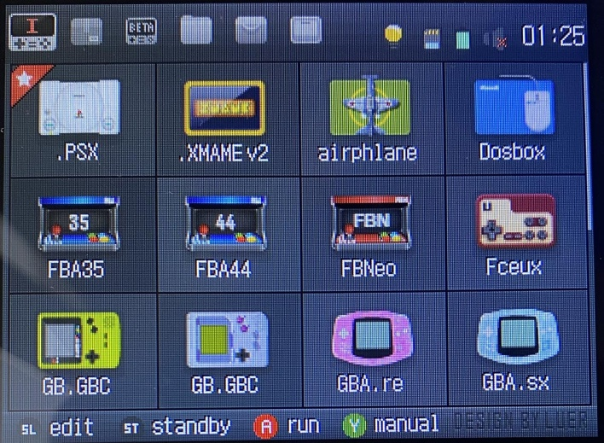

The bottom bar is still for 5 seconds to display the operation button description

Selecting the bottom bar of the emulator will display the shortcut key description

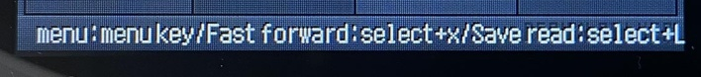

The top bar contains 6 tabs OPKs (Emulators, open source game, test game, Favorites, application,Settings) and status icons (Brightness, TF card, battery, volume, time)

By pressing the L and R shoulder buttons, the current tab can be changed.

The D-pad can be used to navigate through the current tab's OPKs.

GKDmini By pressing the START button, the screen can be turned off.

GKD350H By pressing the L1+R1 button, the screen can be turned off.

By pressing the Y button, the user's manual is displayed. If you are unfamiliar with the emulator settings, please consult the manual. This is critical for beginners.

**2. How to run games**

Press the A button to launch an emulator. Most emulators will show a ROM list after the emulator is launched.

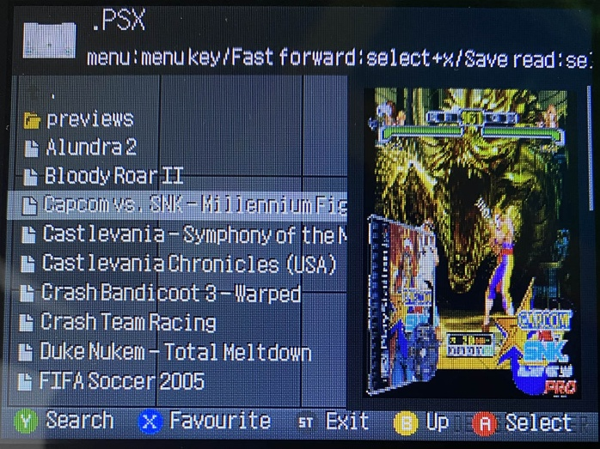

Follow the instruction on the bottom of the screen. To select ROMs, use the Up and Down buttons. To go back and forth between pages, use the Left and Right buttons. To load the selected ROM, press the A button.

If box art or video previews are available (in the ROM directory's preview folder), they can be viewed when browsing the ROMs.

Some game OPKs can be played without the use of emulators. When you launch these OPKs, make sure to follow the instructions provided.

FBA and FBN. The arcade emulators include FBA35, FBA44, and FBN. The cores of the FBA35 and 44 are different, and one can support different ROMs better than the other. Cheat support is available in FBA44 and FBN, but not in FBA35.

The directories are displayed on the first tab in FBA and FBN. The categories of ROMs can be found by opening the directories. For ROMs with English names, the favorite and preview functions are available. In FBA and FBN, the third tab displays a list of ROMs (native mode).

**3. Configure OPKs**

With default configuration, it is possible that the directory of ROMs and the OC settings are not configured correctly. In that instance, choose the OPK and press the SELECT button to change settings.

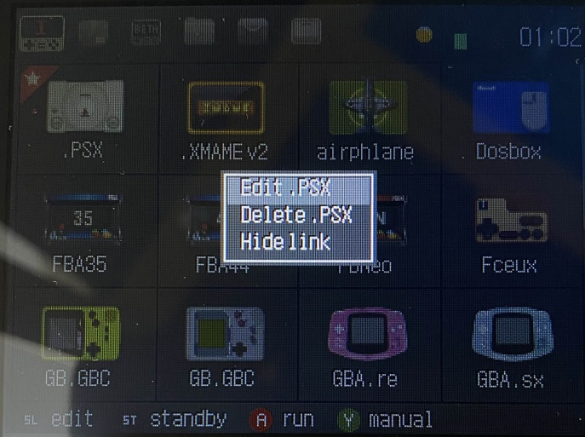

The functions include Edit XXX, Delete XXX, Hide XXX

Edit XXX is the most common command we use. If you are not sure what you’re doing, don’t use other commands.

Press Edit XXX

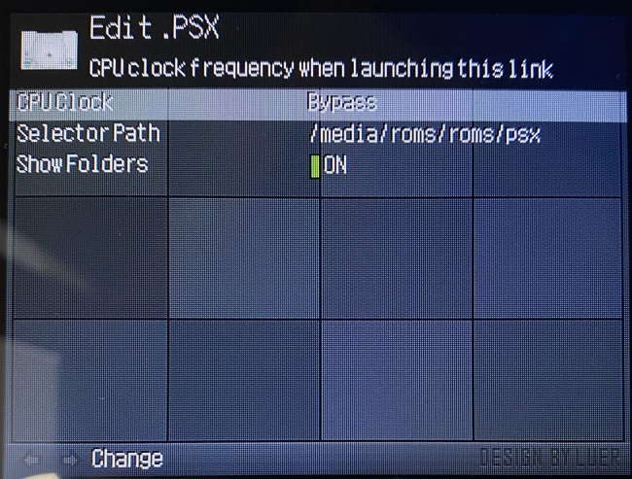

Here we can set the CPU OC level, ROM directory, and directory display on/off.

OC level of the CPU: You can increase the OC to increase the FPS if the ROM you wish to play is difficult to emulate

Directory of the ROMs: Select the default ROMs directory. Once it’s configured, you won’t need to select the directory every time you use the emulator.

ON/OFF of directory display: You can enable this option if the ROM directory has subfolders / categories (e.g., RPG, action, shooting). Subfolders and categories will be displayed.

Note: save the configurations by pressing the START button.

**4. Shortcuts of favorite games**

You can add ROMs to your favourites list by pressing the X button when browsing the ROMs.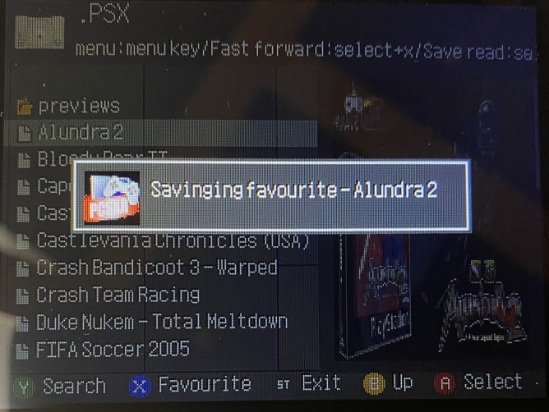

The favorite ROMs can be found under the home menu’s Favorites tab.

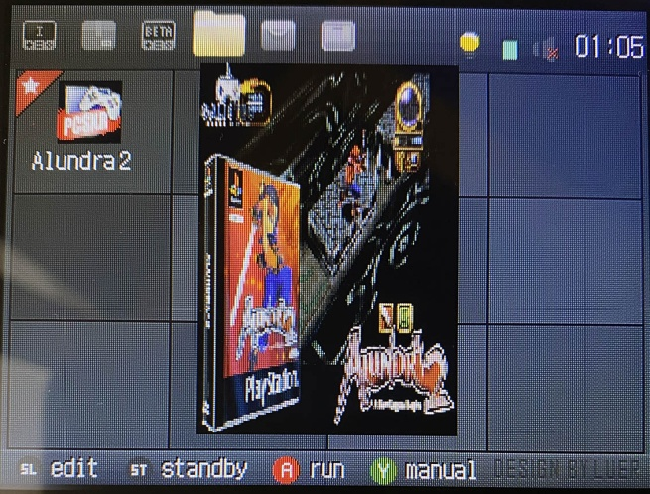

The settings of favorite ROMs can also be changed by pressing the SELECT button.

**5. OC modes for the CPU**

The OC can be set from Level1 to Level6. OC is not enabled in the Bypass mode.

It is possible to set different OC modes for different ROMs.

**6. Beginner mode**

Beginner mode is for emulator/Linux/OpenDingux newbies who don't want to spend time fiddling with sophisticated settings and just want to play games. Most unnecessary settings are hidden under the beginner mode to make the UI simpler and cleaner.

How to turn this mode On and Off: Under the home menu’s settings tab, enter the Settings OPK, turn the mode on and off.

**7. USB mode**

Entering USB mode allows you to access files on the device just like you’re using a USB flash drive.

How to enter the mode: Under the home menu’s settings tab, select USB mode and press the A button.

Once it’s turned on, you can connect the device with your PC with a USB cable.

**8. Device Settings and Settings**

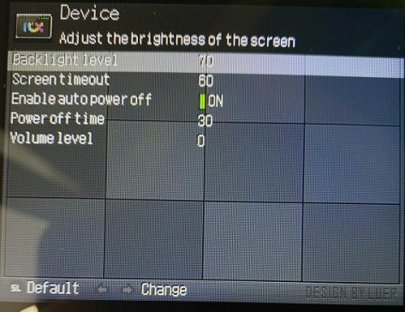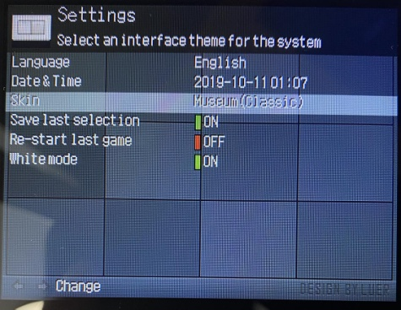

Theme modification

Device Settings: adjusting some hardware settings such as backlight level, volume, screen turn-off time, and shutdown time

Settings: adjustments to the OS such as language and theme

**9. About**

Check the UI development log and other information

